ATTACHMENT-4
INFORMATION DOCUMENT ABOUT THE HOT GAS GENERATOR

GENERAL INFORMATION ABOUT HOT GAS GENERATOR
Hot Gas Generator (HGG) is a pyrotechnic capsule that will be provided to the competing teams by the TEKNOFEST Competition Committee. Teams planning to create pressure using pyrotechnic materials as part of the recovery system can use the HGG to be provided by the Competition Committee in accordance with the competition specifications.
Since it is a ready-made product, no intervention to the contents of the capsule will be permitted.
The mass of the HGG is 78g+/-5g.
Teams will install the system using the bolts and apply tension to the connection points of the generator. Teams are not required to do any operations except final wiring and bolt installation.

HGG CONNECTION INTERFACE
The HGG comprises two main parts: the connection interface, and the pyrotechnic capsule. The HGG can be mounted through its connection interface (clip on the HGG). It will be sufficient for the teams to bolt the connection interface to their rockets as a mechanical connection, after which the capsule can be connected to the interface with clips. The activation of the capsule will require two (2) cable connections.
The assembled version of the HGG is shown in Figure 1. As can be seen, the clip on the bottom of the capsule will slot into the interface, completing the installation.
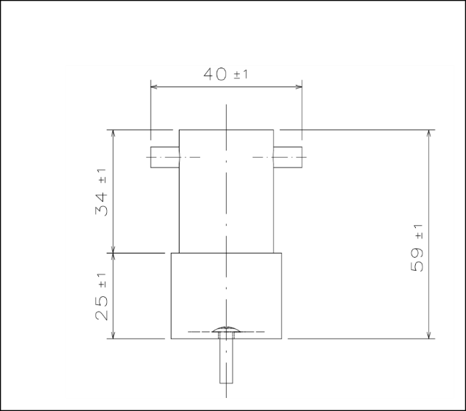
Capsule and Connection Interface (Assembled)
Figure 1. HGG and Connection Interface (Assembled)
The image of the pyrotechnic capsule is shown in Figure 2. The parts shown here with number 1 will be used to activate the pyrotechnic material. Teams will connect the cables of their systems to these points to provide electrical connection.
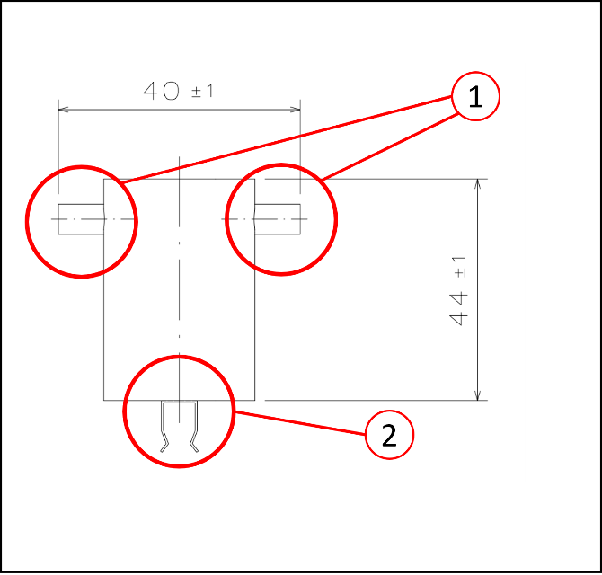
Pyrotechnic Capsule
1. Electrical Connections
2. Interface Connection Clip
Figure 2. Pyrotechnic Capsule
The installation will be completed after placing the pyrotechnic capsule on the connection interface with the help of the clip underneath. The connection interface into which the pyrotechnic capsule will fit is shown in Figure 3. The connection interface will contain a hole that will allow the teams to easily mount the interface to their systems. This hole is designed to allow an M4 bolt to pass through. For the connection in question, raised head bolts should be preferred.
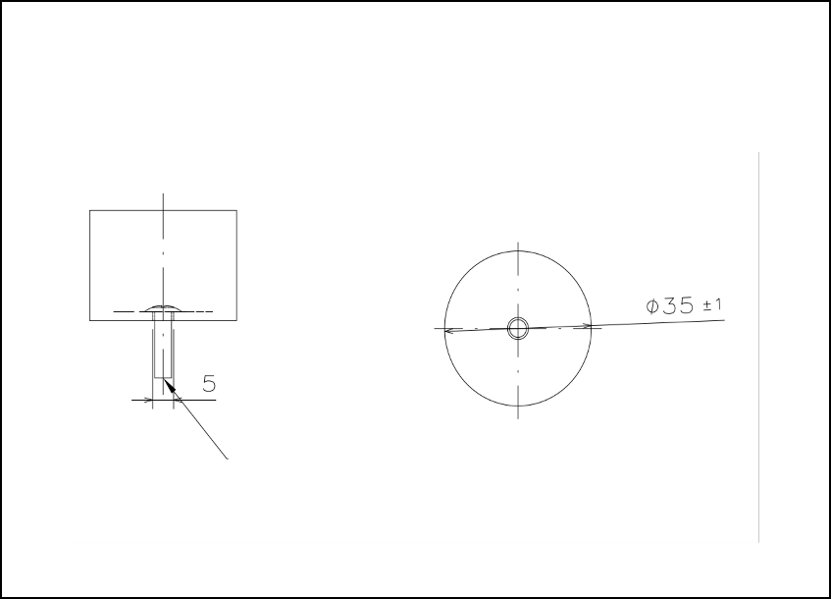
Connection Interface
M4 Raised head bolts

Figure 3. Connection Interface

HGG CURRENT VALUES
Hot Gas Generator current charts are given in Figure 4, 5, 6 and 7.
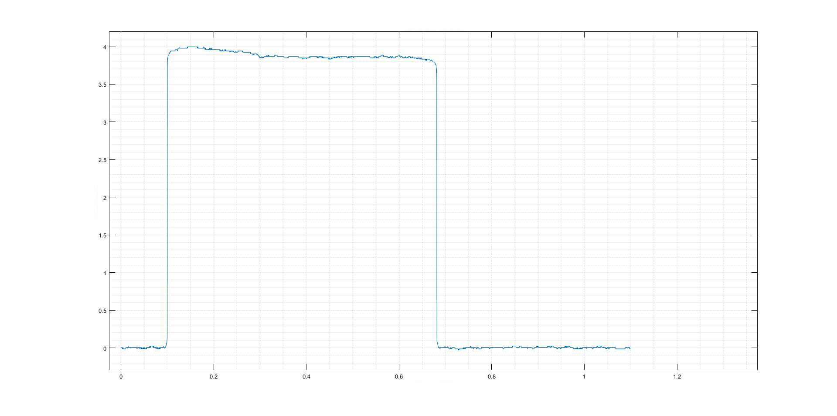
Current [A]
7.0V Current - Time
Time [h]
Figure 4. Current under 7V voltage

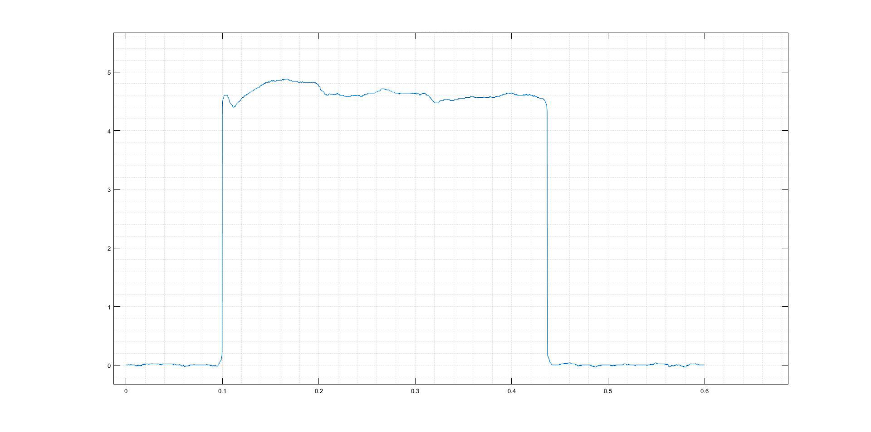
Current [A]
7.0V Current - Time
Time [h]
Figure 5. Current under 8.4V voltage

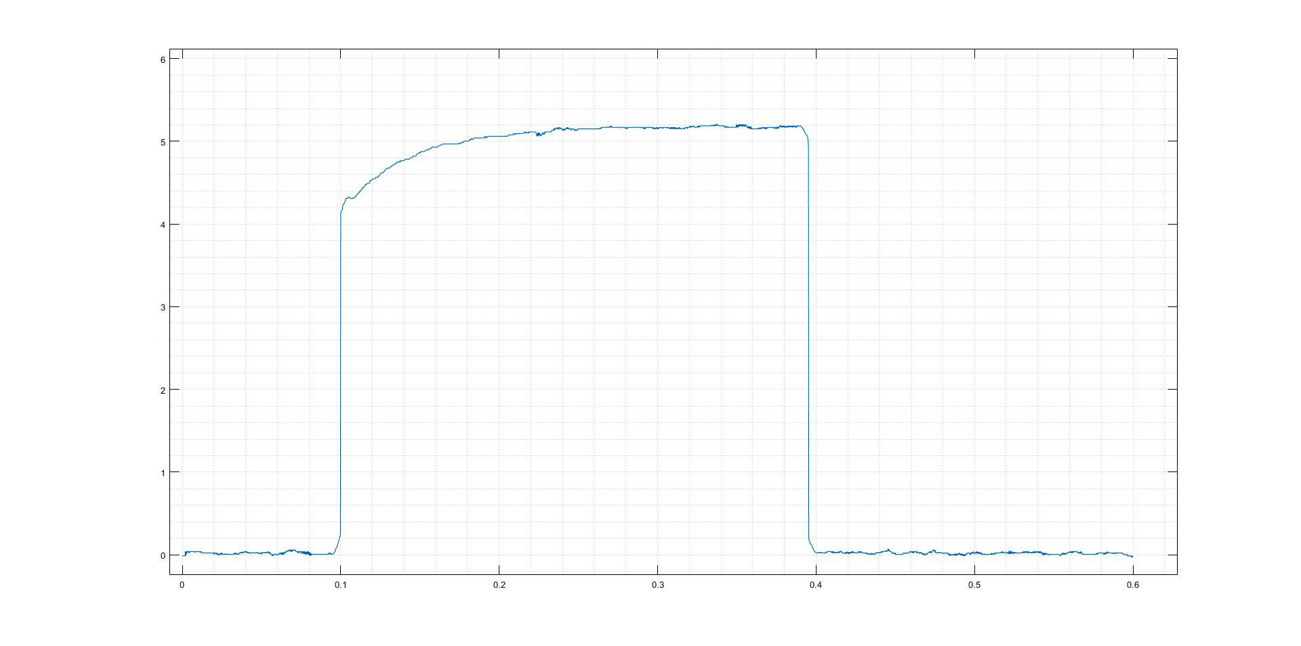
Current [A]
7.0V Current - Time
Time [h]
Figure 6. Current under 11.1V voltage

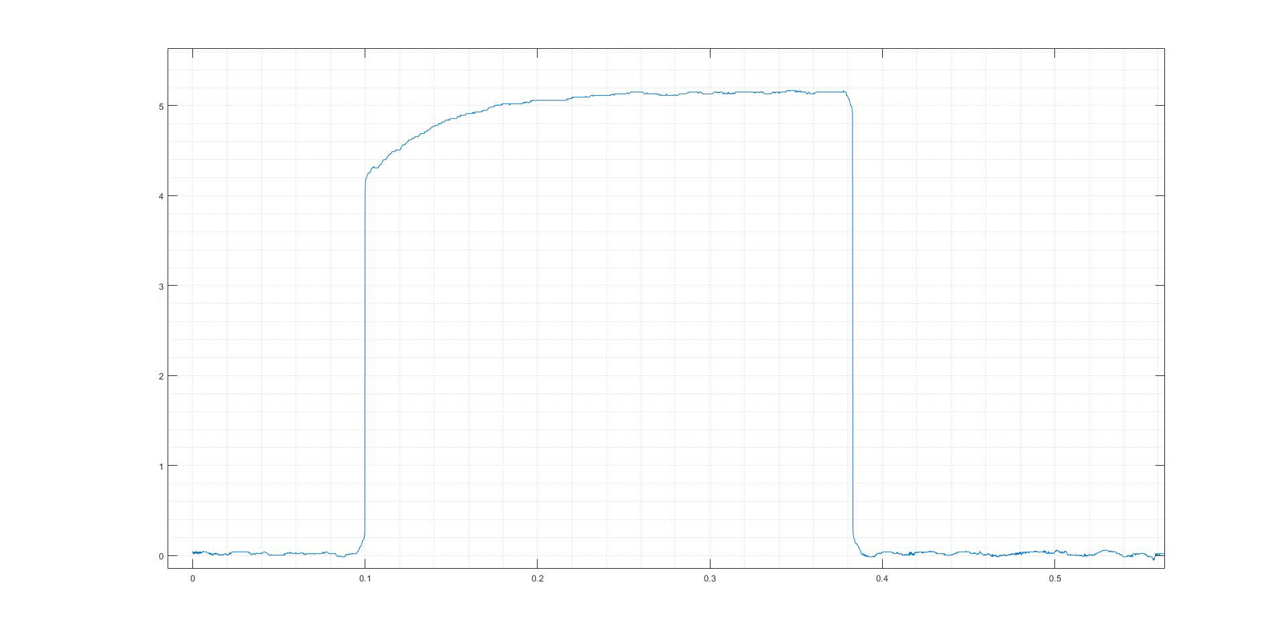
Current [A]
7.0V Current - Time
Time [h]
Figure 7. Current under 12.6V voltage

HGG PRESSURE VALUES
The pressure graph following from the activation of the HGG within a 1-litre closed control volume is shared in Figure 8.
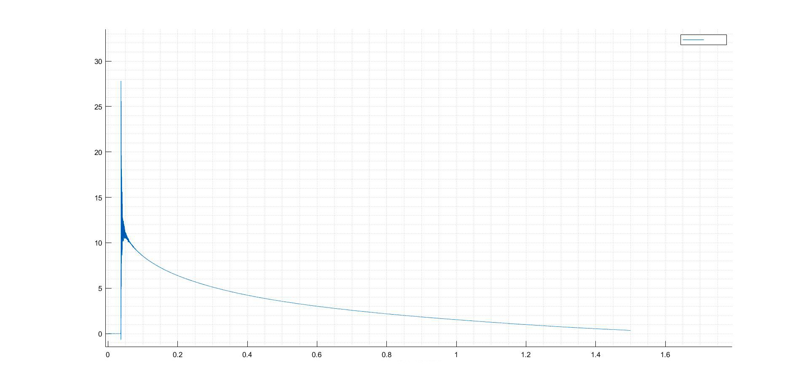
Pressure [bar]
SGU Pressure - Time
Time [h]
Pressure

